Solution Architecture

Date | 06 July 2026
Team ID | xxxxxx
Project Name | OptiCrop: Smart Agricultural Production Optimization Engine
Maximum Marks | 5 Marks

Solution Architecture Diagram:
Provide a high-level visual representation of your solution's architecture. Use the structural layout below as a template to map out your Presentation Layer, Application Layer, and Data Layer. Fill in the specific technologies and components for your project directly into the boxes to create your architectural
diagram.
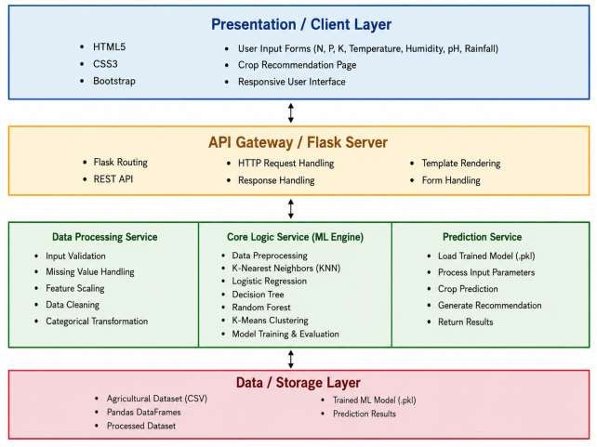

Component Description Table

Component Name | Description / Role in Architecture | Technologies Used
Presentation Layer | Provides the user interface where users enter soil and environmental parameters and view crop  recommendations. | HTML5, CSS3,  Bootstrap
API Gateway | Receives user requests, routes them to the backend, and returns prediction results. | Flask, REST API
Application Layer (Business Logic) | Validates user inputs, preprocesses data, loads the trained machine learning model, predicts the best  crop, and generates recommendations | Python, Flask, Scikit-learn, Pandas, NumPy
Data Layer | Stores the agricultural dataset and trained  machine learning model used for prediction and analysis. | CSV Dataset, Pickle (.pkl), Pandas

